LAB 9

Exercise 1:

**Lab report**: By default (before your changes to the configuration file), will the SNMP service allow connections from remote hosts? Explain what the effect of your change to the agentAddress option will be.

Yes, if we change the AgentAddress we are allowing connections from all the hosts with public IP

**Lab report**: Explain how the lines work together. What MIBs can be read using the "public" community string? What MIBs can be edited using the "public" community string?

view systemonly included .1.3.6.1.2.1.1

view systemonly included .1.3.6.1.2.1.25.1

The above two lines add system and hrsystem group to view

rocommunity public default -V systemonly

This command is used to change the configuration

**Lab report**: What is the effect of adding the line

rocommunity secret 10.10.1.0/24

to the configuration file?

By using this command we make sure that only the host of the subnet 10.10.1.0 – 10.10.1.255 will be allowed read/write

**Lab report**: What is the data type and the description of the MIB objects

 IF-MIB::ifDescr : octet string - a text string that contains the information about the

interface.

 IF-MIB::ifInUcastPkts, : counter - Number of unicast packets delivered from this layer to a higher sublayer.

IF-MIB::ifPhysAddress - The interface address at its protocol sublayer.

IF-MIB::ifOutUcastPkts?- Counter - Total number of unicast packets that were requested by the higher layer including the packets that were discarded/not sent

Exercise 2:

Romeo Public:

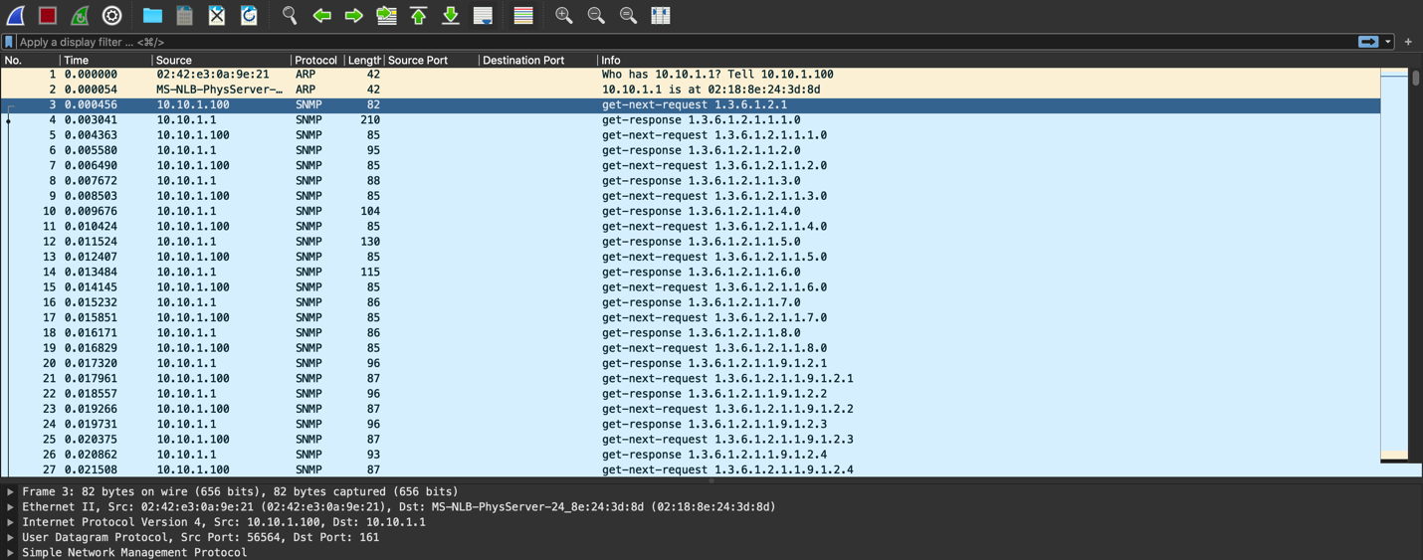

Juliet Public:

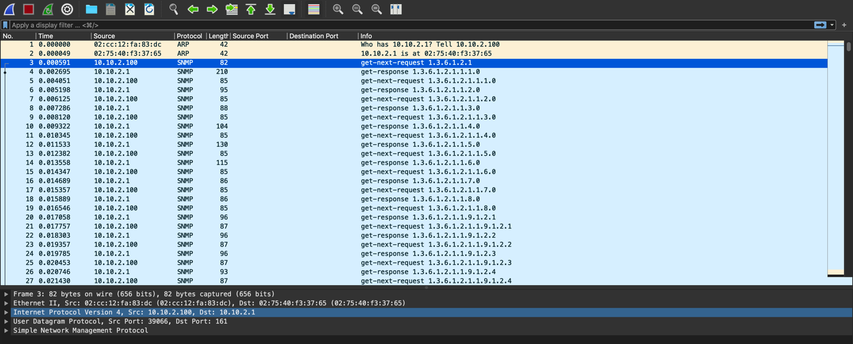

Romeo Secret

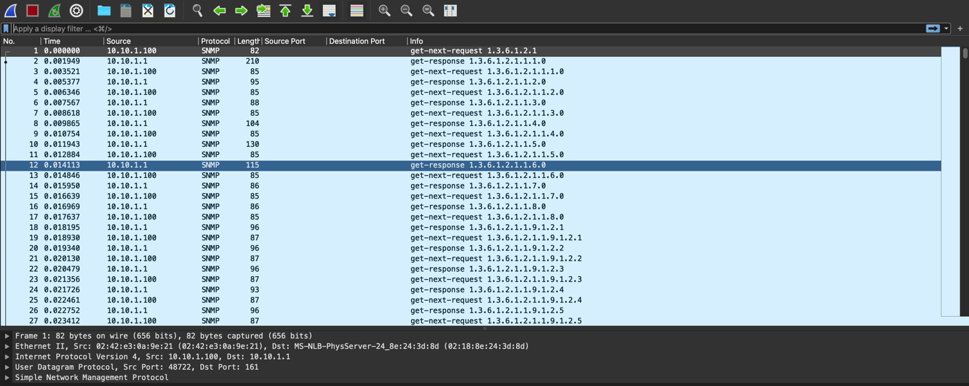

Juliet Secret

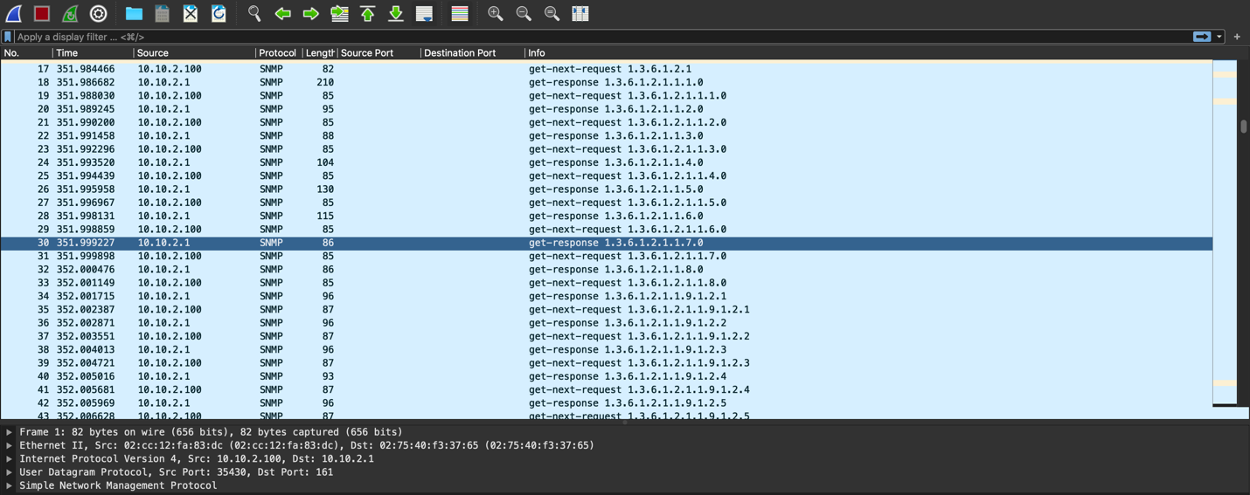

1. **Rocommunity public localhost** :gives full access to the local host   
   **systemonly** : gives access to basic info  
    By commenting *rocommunity* and uncommenting *systemonly*, while using public as the community string, we get basic info and while using secret string we get full read access to snmpv3 for host in 1010.1.0/24.
2. In public string Juliet gives the output similar to Romeo. In secret community string we can see that the secret string defines the range of address from **10.10.1.0 - 10.10.1.255.** We get “*Timeout: No Response from router*” from Juliet as Juliet does not exist in this range.

Exercise 3:

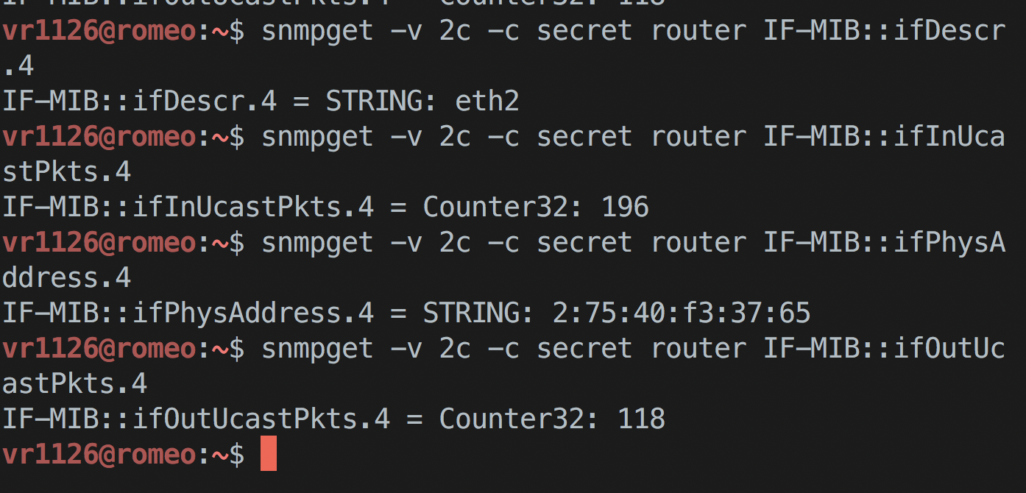

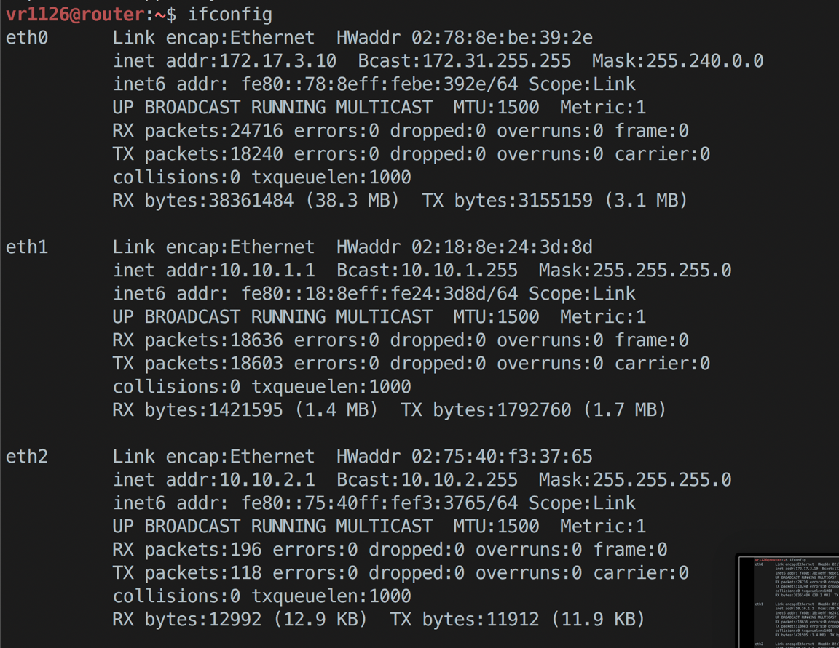

**Lab report**: Show the relevant section of the ifconfig output on the router, and how it corresponds to the interface information you collected using SNMP.

From the IFConfig screenshot above, **IF-MIB::IfDescr** tells us that host is connected to **eth2** and ifPhysAddress tells us that address is **2:75:40:f3:37:65**

**Lab report**: Draw the format of one of the (successful) SNMP response messages saved, including the name and value of each field.

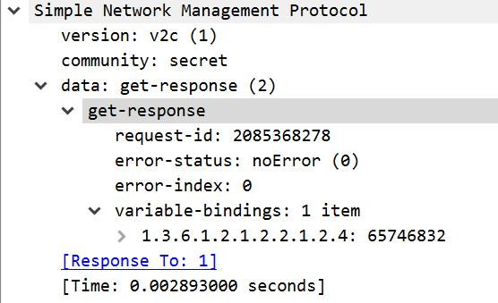

Exercise 4:

1. We can see the username as shown below (Telnet)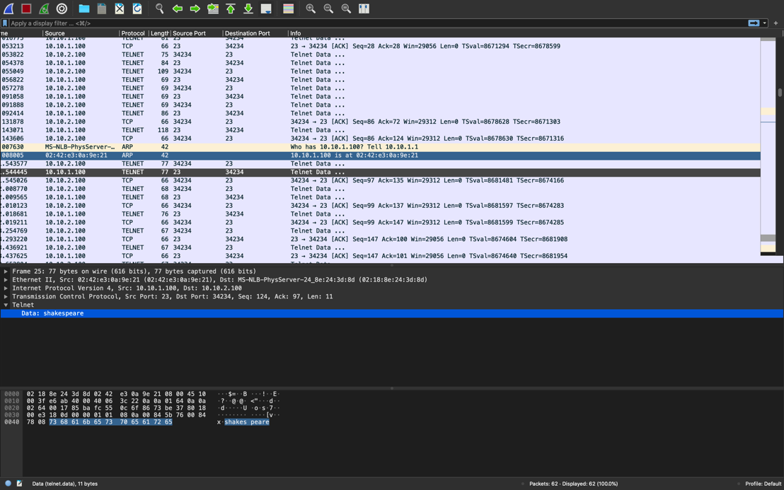

Password in telnet:

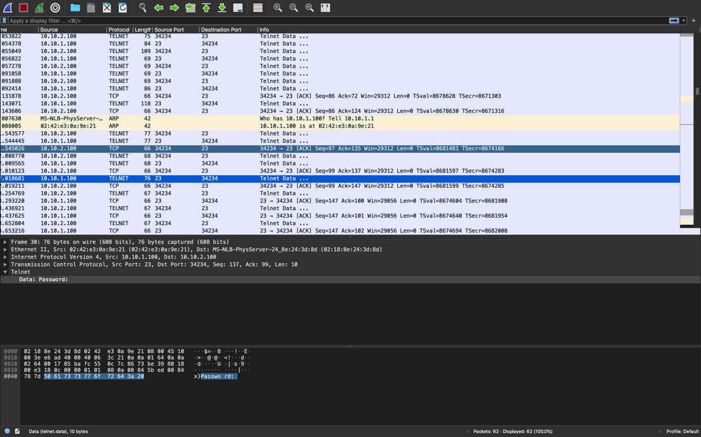

1. SSH- Both password and username are encrypted as show in the screenshot below:

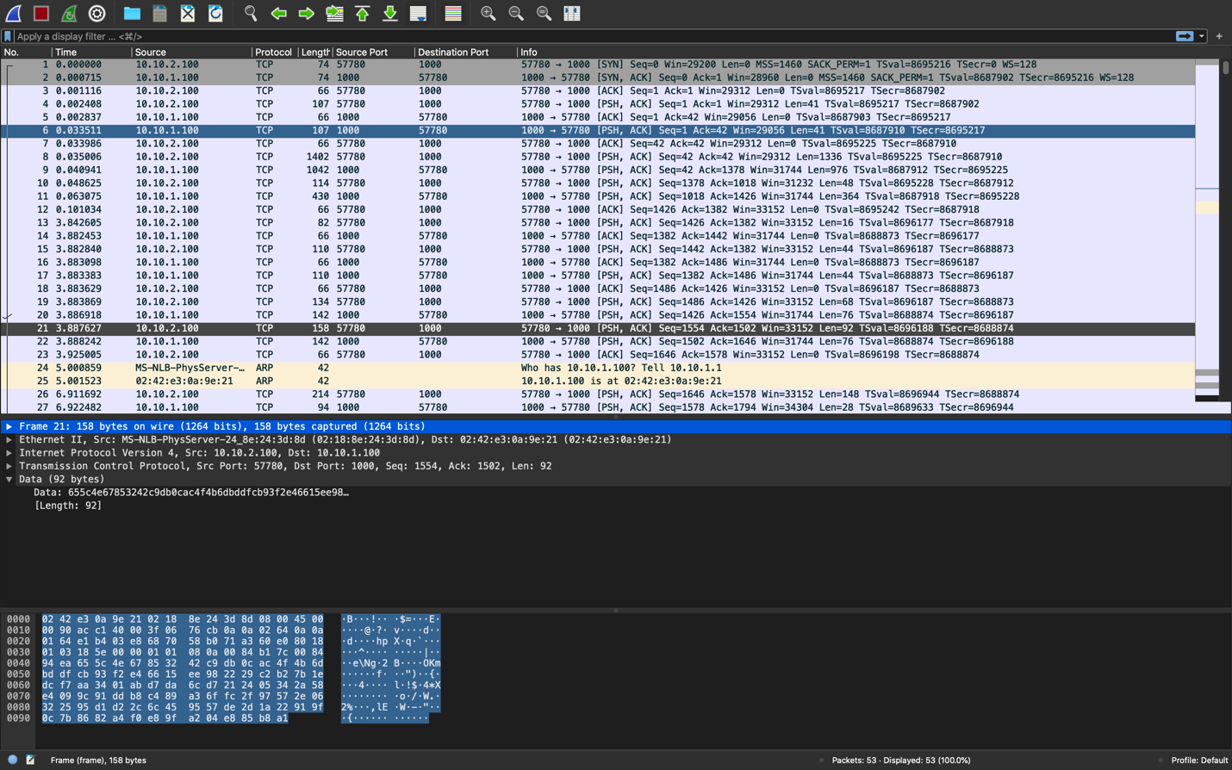

1. SSH uses public/private encryption and mac to authenticate that’s why it is more secure

than telnet which sends information over clear text.

Exercise 5:

1. We can see the requested data in this

1. Data is encrypted in this case

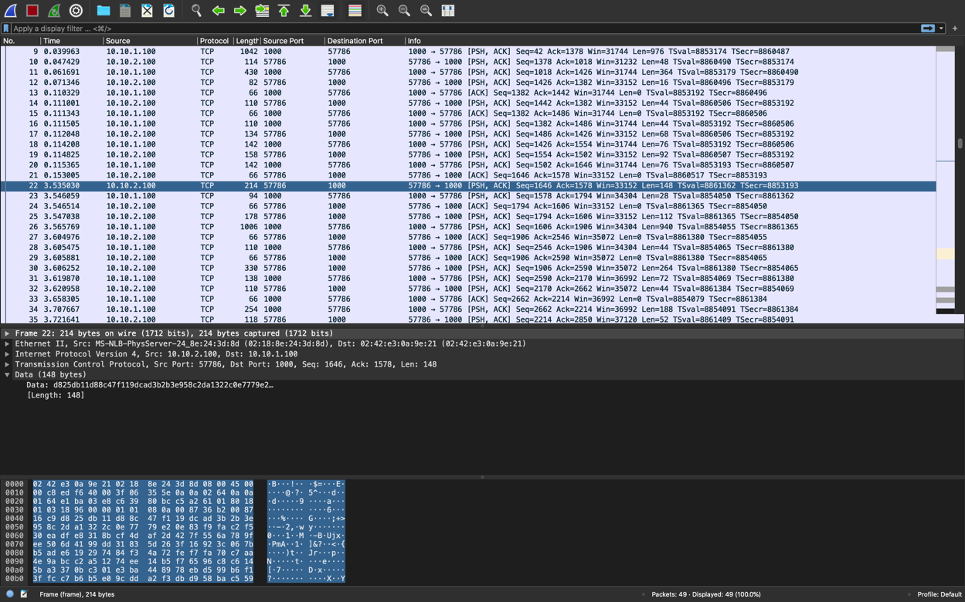

1. SFTP is more secure as it uses SSH to transfer data so has all the benefits of SSH

Exercise 8:

**Before appending:**

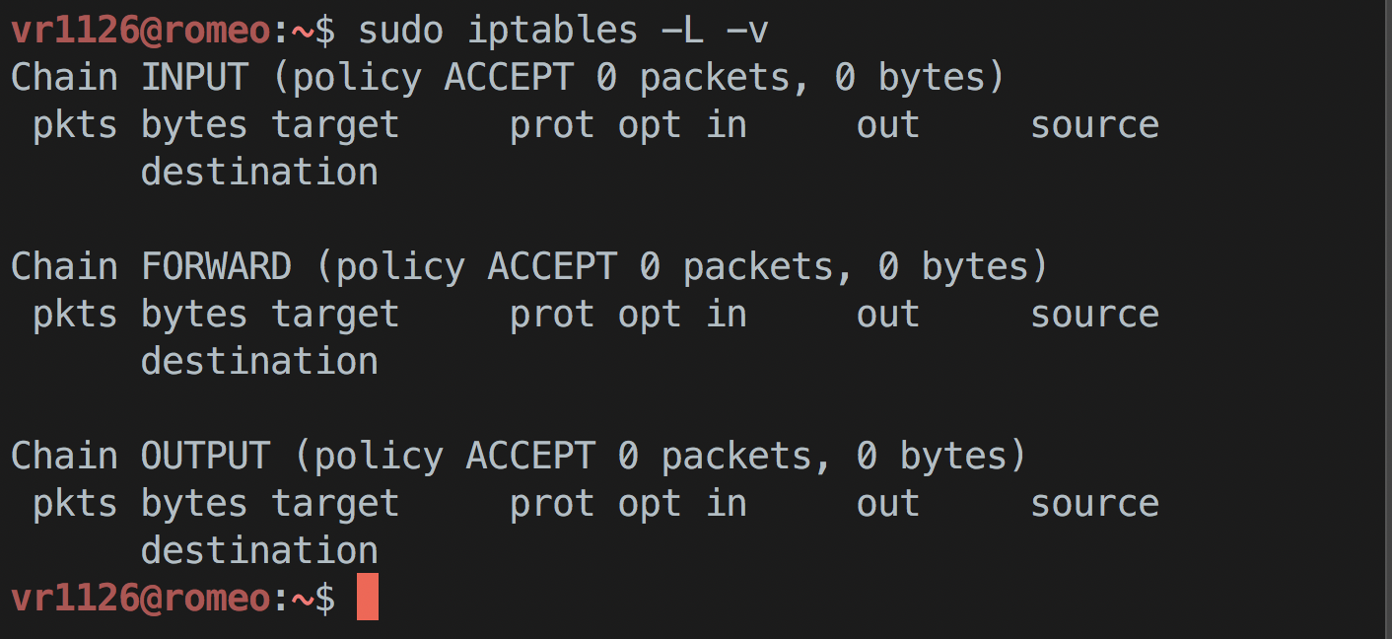

**After:**

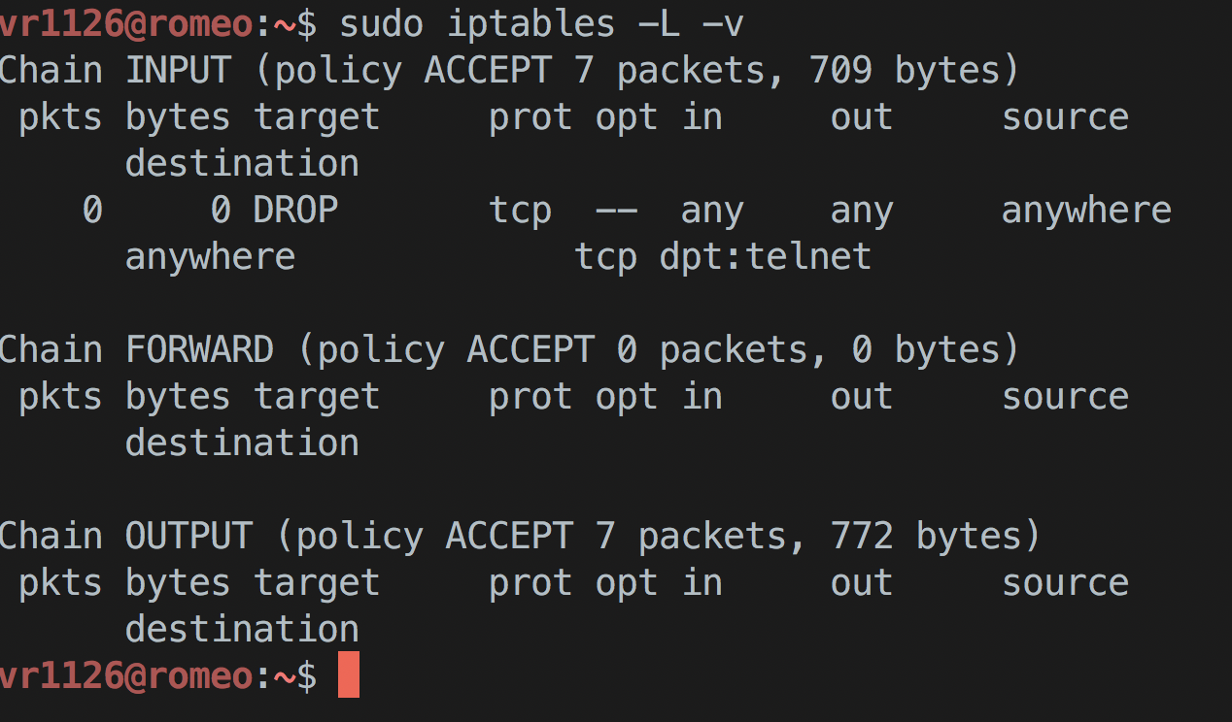

1. No, we cannot telnet to the remote machine because we added a rule to drop packets on that port 23. Since telnet uses this port, we cannot connect.

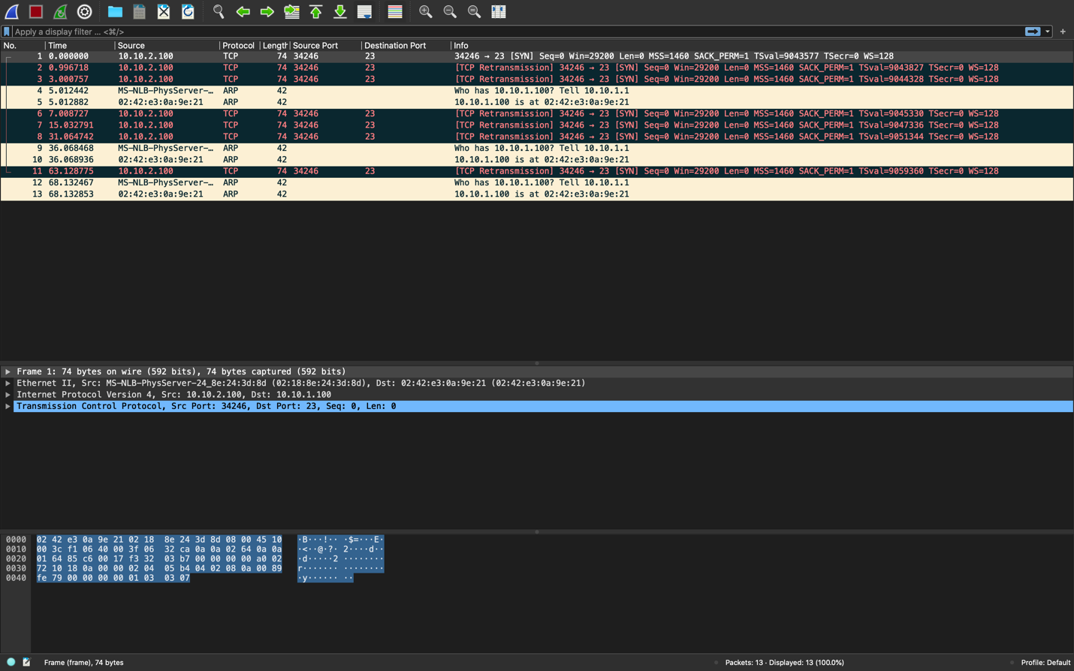

1. We can see that 6 retransmissions were attempted, and timer is doubled every time using exponential back-off algorithm. (3,7,15,31,63)

Exercise 9:

1. Here the packet was rejected instead of dropped, the server sets a reset flag and tell the client to reset the connection

